In Memory of Bradford Fernandez, our beloved son, brother and friend, we invite you to a:
THE

BRADFORD

F
OUNDAT ION

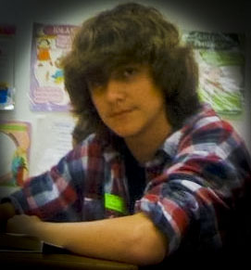

We will meet, after the service, at Sunrise Athletic Club (SAC: 11501 NW 44th St. Sunrise, FL 33323) for a time of fellowship and sharing a meal together. At 9 pm, balloons will be released into the sky in remembrance of Bradford and all those who have died by suicide.

** Please bring a pot luck item to the park **
Chips and Salsa (Mild and/or Medium)
Chex Mix Snacks or other Snacks
Little Cesar’s Pizza (Cheese or Pepperoni) and Crazy Bread
Apple Pie, Pecan Pie, or any prepared desert
Twinkies (Bradford’s favorite!)

Contact: Ana Fernandez 954-865-1329
Email: ana@inmemoryofbradford.org
Visit: www.inmemoryofbradford.org

Items you can bring for the pot luck:
Publix Friend Chicken
Publix Hot and Spicy Chicken Wings
Publix or Sam’s Roasted Chicken or Ribs
Publix Potato Salad or Chicken Salad
Macaroni Salad
Baked Beans

